<NAME><student ID>
Week 4 – Lab exercises

Task 4.1

- : Assume that data has the value 10. List the actions the computer executes when it runs the following code.
cout<<“Output 0”<<endl; if (data < 15)
{

cout<<“Output 1”<<endl;

}

else

cout<<“Output 2”<<endl; cout<<“Output 3”;
Sequence | Action | Note
1 | cout is used to print ‘Output 0’ on screen
2 | Evaluates the expression (condition of if) data < 15 | Condition is true.
3 | cout is used to print ‘Output 1’ on screen
4 | cout is used to print ‘Output 3’ on screen

- : Assume that data has the value 20. List the actions the computer executes when it runs the following code.
cout<<“Output 0”<<endl; if (data < 15)
cout<<“Output 1”;

else

cout<<“Output 2”;

cout<<“Output 3”;

Sequence | Action | Note
1 | Use the cout with the text ‘Output 0’
2 | Evaluates the expression (condition of if) data < 15 | Condition is false, goes to else
3 | Use the cout with the text ‘Output 2’
4 | Use the cout with the text ‘Output 3’

c). Give the corresponding snapshots of memory after the following set of statements is executed (explain the execution step by step).
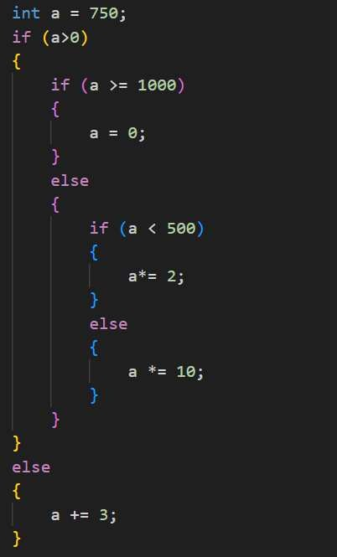

Sequence | Action | Notes or Value of ‘a’
1 | Evaluates the expression (condition of if) data < 0 | Condition is true
2 | Evaluates the expression (condition of if) data >= 1000 | Condition is false, goes to else
3 | Evaluates the expression (condition of if) data < 500 | Condition is false, goes to else
4 | Int a get multiplied by 10
5 | Output will show that a is equal to 7500

Add new rows as necessary.

Task 4.2
Write a C++ Program that reads two integers and displays the biggest number.

Source code

#include <iostream>
using namespace std;

int main()
{
int a, b;

cout<<"Enter a variable for a: "<<endl;
cin>>a;

cout<<"Enter a variable for b: "<<endl;
cin>>b;

if (a>b)
{
cout<<"Variable A is larger than variable B "<<endl;
}
else if (b>a)
{
cout<<"Variable B is larger than variable A "<<endl;
}
else
{
cout<<" A and B are equal "<<endl;
}
}

Screenshot

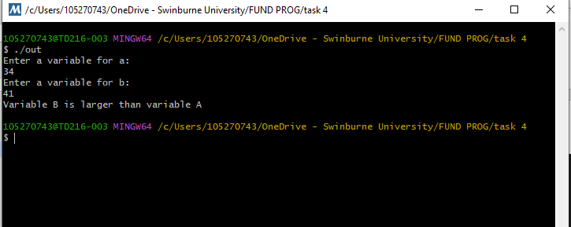

Task 4.3

Write a C++ Program that reads 3 marks of a student namely M1, M2, and M3. The student is to be declared as “Pass” only if the student has scored more than or equal to 60 in all subjects and the average is above 65.

Source code

#include <iostream>
using namespace std;

int main()
{
double a, b , c;
float ave;
//students scores
cout<<"Enter score for M1: ";
cin>>a;
cout<<"Enter score for M2: ";
cin>>b;
cout<<"Enter score of M3: ";
cin>>c;
ave = (a+b+c)/3.0;

if (a>=60 and b>=60 && c>=60 and ave>=65)
{
cout<<"Passed"<<endl;
}
else
{
cout<<"Failed"<<endl;
}
}

Screenshot

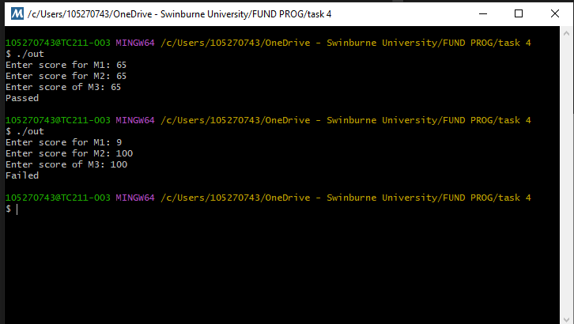

Task 4.4

Write a C++ program that takes an integer score as input and outputs the corresponding grade. The grading system is as follows:
80-100: HD

70-79: D

60-69: C

50-59: P

0-49: F

Source code

#include <iostream>
using namespace std;

int main()
{
int score;

cout<<"Enter a score: ";
cin>>score;

switch(score)
{
case 80 ... 100:
cout<<"HD"<<endl;
break;
case 70 ... 79:
cout<<"D"<<endl;
break;
case 60 ... 69:
cout<<"C"<<endl;
break;
case 50 ... 59:
cout<<"P"<<endl;
break;
case 0 ... 49:
cout<<"F"<<endl;
break;
}
}

Screenshot

